Foundations of CCM2 Name__________________________________

Unit 3 Review

1) If , then ________, __________, AND _________

2) Which pair of triangles is congruent by ASA? 2)_________



1. B.



C. D.

3) Solve for x.

3) ____________________

50

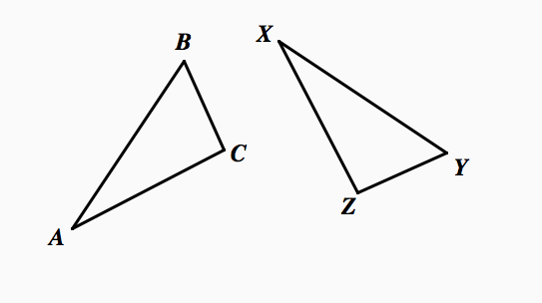

4)In triangles below, $∆ABC ≅ ∆XYZ$.

Which two statements identify corresponding congruent parts for these triangles?

$\overline{AB} ≅\overline{XY} and ∠C ≅ ∠Y$

1. $\overline{AB} ≅\overline{YZ} and ∠C ≅ ∠X$ 4)

$\overline{BC} ≅\overline{XY} and ∠A ≅ ∠Y$



$\overline{BC} ≅\overline{YZ} and ∠A ≅ ∠X$

_________

5)Use the information in the figure below to solve for x. 5)_________

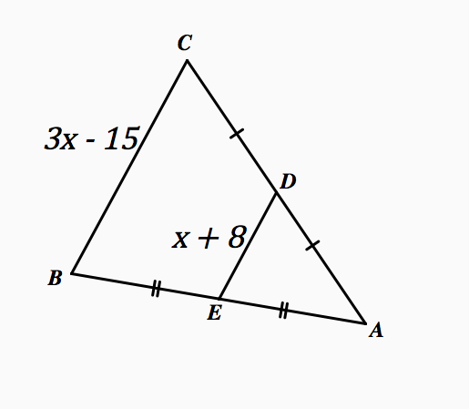

6)What are the rigid motions? 6)_________________________________________________

7) State whether each triangle is congruent or not. If they are state which postulate or theorem that proves they are congruent.

a) b) c)

1. ___________________ b) ____________________ c) __________________

8) Find m<ABC:

8) ____________________

9) If ABCDE ~ VWXYZ, then:

(a) Find the scale factor of ABCDE to VWXYZ. _________

6

(b) Find the values of *r* and s. *r* = _______

*s* = _______

8

What’s wrong with this picture? Explain why the information cannot be correct.

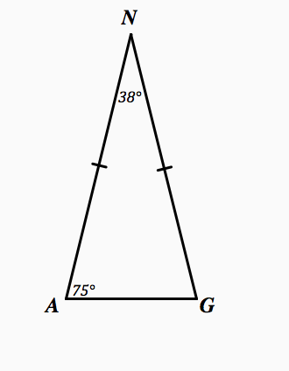

Write complete sentences: _____________________________________________

_____________________________________________

_____________________________________________