UNIT 2: Similarity and Congruence |  | HOMEWORK
9/19  Monday | Sum of Angles and Triangle Theorems  Pages 1-5
9/20  Tuesday | Equilateral and Isosceles Triangles  Pages 6-10
9/21  Wednesday | Similar Polygons  Pages 11-14
9/22  Thursday | Similarity  Pages 15-20 QUIZ
9/23  Friday | Mid-segment of a Triangle  Pages 21-25
9/26  Monday | Congruence and Rigid Motions  Pages 26-31
9/27  Tuesday | Congruence Postulates –SSS, SAS, ASA, AAS, HL  Corresponding Parts  Pages 32-36
9/28  Wednesday | Review and Vocabulary  Pages 37-42 | Study for Test
9/29  Thursday | Unit 2 Test
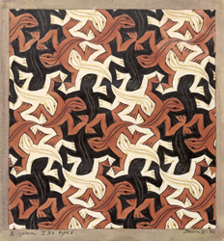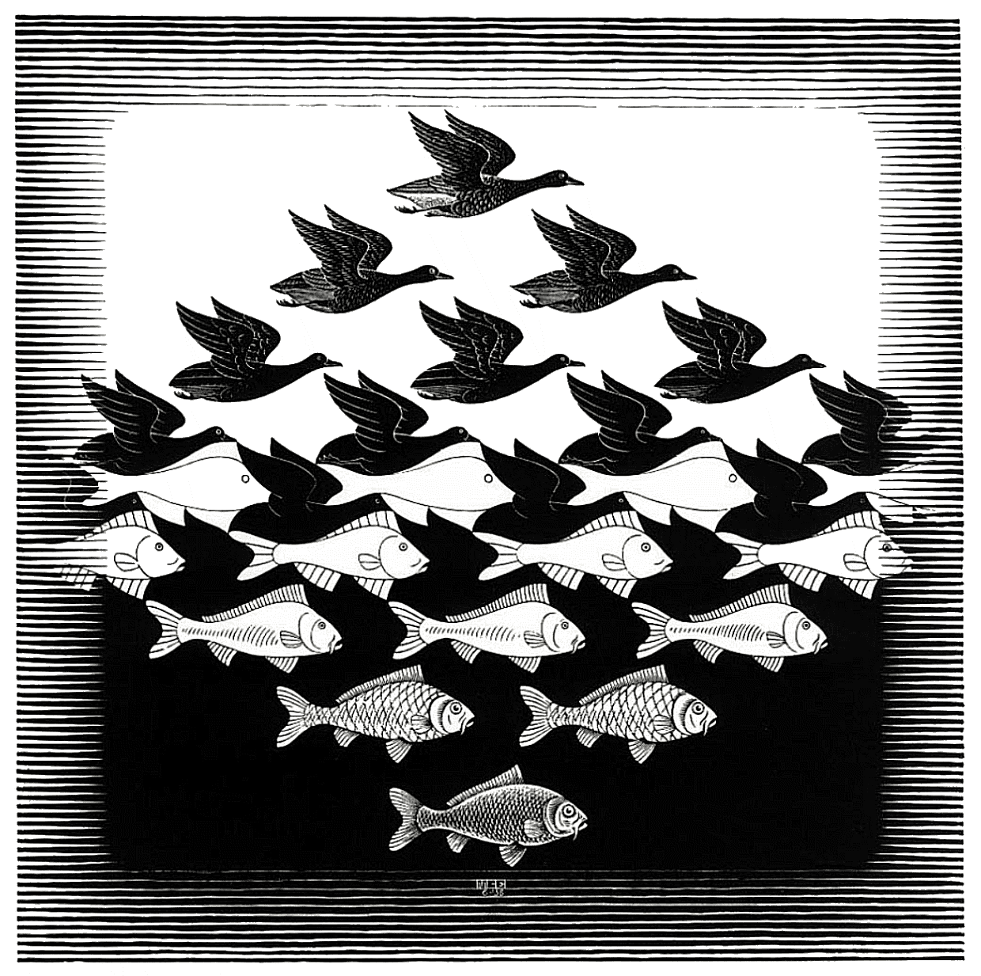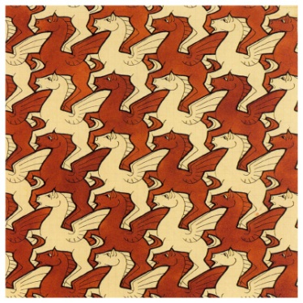
Lizard Sky and Water Pegasus Reptiles

Works by M. C. Escher

